BRIEFING NOTE
14/12/2021 –BRI/21/KH/34804

SpERCs - Specific Environmental Release Categories

CropLife Europe (the former European Crop Protection Association, ECPA) has developed Specific Environmental Release Categories (SpERCs) for the environmental exposure assessment of substances used as co-formulants in plant protection products (PPP). The CLE SpERCs cover the conditions of outdoor and indoor use of a co-formulant in plant protection products by professionals and consumers. The background documentation of the CLE SpERCs has been published (Dobe et al. 2020).

The CLE SpERCs and associated release factors were developed for use solely with REACH nested multimedia mass balance models (“EU TGD based models”), as part of the regional scale assessments, whereby emissions from all identified uses of a substance are considered. Use of the CLE SpERCs allows the co-formulant emissions from PPP to be fully accounted for in the risk assessment of other uses, as well as to consider the contribution from those uses in the local environmental assessment of the PPP use.

A CLE guidance document giving full details on the environmental risk assessments for co-formulants in plant protection products is available on the CLE webpage under the following link: https://croplifeeurope.eu/pre-market-resources/reach-in-registration-evaluation-authorisation-and-restriction-of-chemicals/
Full details on the SpERCs can be found in the published background documentation (Dobe et al. 2020).

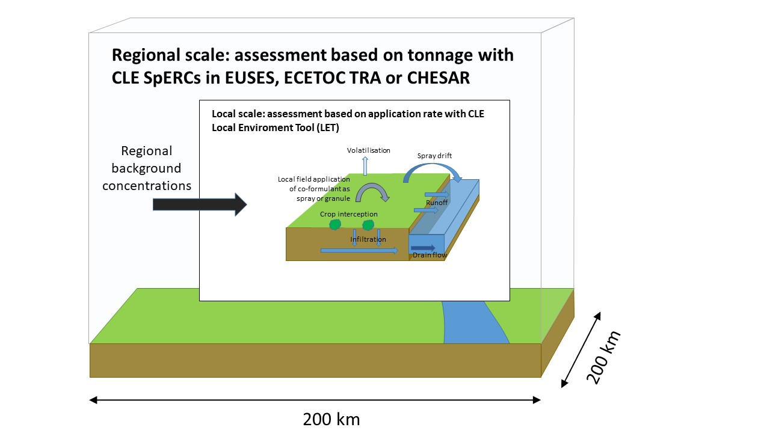

Local environmental assessment

The EU TGD models are mass balance (“tonnage”) based and the key assumption at the local scale is that release to water will be via an industrial wastewater or municipal sewage treatment plant before release to a river. Direct local releases to surface water may be assumed, but direct releases to agricultural soil are not considered and are in fact outside the scope of the EU TGD. As a consequence, the default local exposure assessment approach based on EU TGD does not take account of uses where substances may be directly applied onto agricultural soil, or where other direct emissions to surface water may take place. However, this is relevant for the use of a substance as a co-formulant in PPP.

The LET (Local Environment Tool) approach developed by CLE is a standalone replacement for the local scale nested box in the models based on the EU TGD. Boundary, regional environmental concentrations should be calculated using the CLE SpERCs (e.g. in EUSES, ECETOC TRA, CHESAR) and manually imported into the LET. The local scale environmental concentrations should then be calculated using the LET.

A short webinar explaining the tools and approach developed for co-formulants used in PPP is available: https://www.croplifeeurope.eu/webinars/reach.
The LET tool, and a detailed description of the model and guidance on its use in the local assessment, is available in a guidance document published on the CLE webpage at: https://croplifeeurope.eu/pre-market-resources/reach-in-registration-evaluation-authorisation-and-restriction-of-chemicals/

Anticipated workflow for environmental risk assessment

The foreseen workflow for the use of CLE SpERCs consists of five steps:

Communicate maximum safe application rate (kg/ha) as conditions of safe use on the co-formulant eSDS
Enter the generic exposure scenarios for co-formulant use in the CSR

Add LET output to the contributing scenarios in CSR

Upload the CLE use map file in box 2 of the CHESAR substance file or add the CLE SpERCs to the finalised environmental risk assessment in ECETOC TRA or EUSES and calculate PEC_{regional}

Transfer PEC_{regional} to CLE LET for local assessment and calculate PEC_{local}

It is anticipated that the assessor calculates the regional environmental concentrations (PEC_{regional}) in a suitable tool (e.g. EUSES, ECETOC TRA, CHESAR), by using the CLE SpERCs and associated release factors. The calculated PEC_{regional} are then transferred into the CLE LET and used as the regional background concentrations in the calculation of the local predicted environmental concentrations (PEC_{local}). The LET also calculates the safe co-formulant application rate (in kg/ha). The outputs of the CLE LET, i.e. safe co-formulant application rate, PEC_{local} and conditions of use, are then transferred to the respective contributing scenarios in the CSR. The safe co-formulant application rate (in kg/ha) should be communicated in the supply chain as the safe condition of use on the co-formulant extended Safety Data Sheet (eSDS).

CLE created a use map file in version 3.6 of the CHESAR tool, which contains the CLE Generic Exposure Scenarios and the CLE SpERCs. The use map file is available on the dedicated CLE webpage (https://croplifeeurope.eu/pre-market-resources/reach-in-registration-evaluation-authorisation-and-restriction-of-chemicals/) and also in the use map library on the ECHA webpage (https://echa.europa.eu/csr-es-roadmap/use-maps/use-maps-library). The CLE use map file can be uploaded in box 2 of a substance file in CHESAR. The respective substance file should also contain all other identified uses of the substance, to perform the regional scale environmental assessments and calculate PEC_{regional}. The CHESAR tool can be used to generate the exposure scenarios and/or the complete CSR. The calculated PEC_{regional} from CHESAR are transferred into the CLE LET and used as the regional background concentrations in the calculation of the PEC_{local} for the co-formulant use of the substance. The outputs of the CLE LET are then transferred to the respective contributing scenarios in the CSR, by overwriting the co-formulant use scenario created with CHESAR. The safe co-formulant application rate (in kg/ha) should be communicated in the supply chain as the safe condition of use on the co-formulant extended Safety Data Sheet (eSDS).

Further reference:
Dobe et al. 2020, REACH Specific Environmental Release Categories for plant protection product applications. Integrated Environmental Assessment and Management, DOI:10.1002/ieam.4251
Dobe et al. 2017, Development of REACH Generic Exposure Scenarios for substances used as coformulants in plant protection products. Risk Analysis 37(5), 930-942, DOI:10.1111/risa.12666

